[Type sidebar title]
[Type the sidebar content. A sidebar is a standalone supplement to the main document. It is often aligned on the left or right of the page, or located at the top or bottom. Use the Drawing Tools tab to change the formatting of the sidebar text box.]
Ms. Escobar
Grade 5
kescobar@asheboro.k12.nc.us

Classroom Newsletter
December 12, 2016



Monday | Tuesday | Wednesday | Thursday | Friday
Dec. 12 | Dec. 13  Make sure you have your Tiger Tickets at school because you go to the Christmas Store today to shop with them. | Dec. 14  Ms. Durrant will substitute. | Dec. 15  5th grade Chic-fil-A night  All proceeds from tonight go to our grade level. I will be there from  5 – 5:45. | Dec. 16
Dec. 19  I won’t send a newsletter home this short week.  Students should just read 20 minutes and study times tables for homework. | Dec. 20  Stem Day at school. | Dec. 21  School dismisses at 12:30 to start our break. I’ll see you back on Tuesday, January 3.

This Week’s Homework

MATH: Make sure your child brings the math notebook home every night.
Monday – Comparing Decimals to the Thousandths Place, top of worksheet
Tuesday - Mystery Decimals problems 16 – 18, bottom of yesterday’s worksheet
Wednesday – Exit Slip 5.NF.1 half-sheet worksheet
Thursday – Formative Instructions and Assessment Tasks Candy Conundrum worksheet

SCIENCE: Please make sure your child studies all the terms on page 64 titled Heat Cloze from the science vocabulary notebook for a quiz Friday.

Monday– Read the It’s Falling worksheet, and write a 5 word summary of each paragraph beside the paragraph for all of the paragraphs on the sheet.
Tuesday– Read the What is Heat stapled reading selection and make a graphic organizer for each of the two text sections.
Wednesday– Read The Water Cycle worksheet and complete the chart in the science activity section.

READING: Read 20 minutes for pleasure nightly.

What We’re Studying
Literacy/SS – nonfiction text structure: cause/effect, problem/solution, chronological order, compare/contrast, and sequencing PLUS context clues: definition, example/explanation, synonym/antonym, inference/logic, and list/series
Math – relate fraction multiplication to whole number multiplication and understand that fractions can be interpreted as division of the numerator by the denominator,
Science – types of winds: sea breeze, land breeze, El Nino, La Nina, and Gulf Stream

The students would like have a Silly Santa exchange next Wednesday. Please send in a goofball gift that does not cost any money, just your time and creativity, like a picture made of dryer lint or an ornament for the tree made from a paper towel roll you cut and colored. 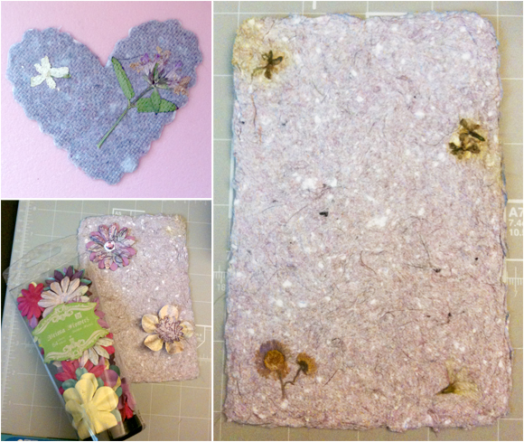



Today is Day 11 of Encore.

Today is Day 10 of Encore.
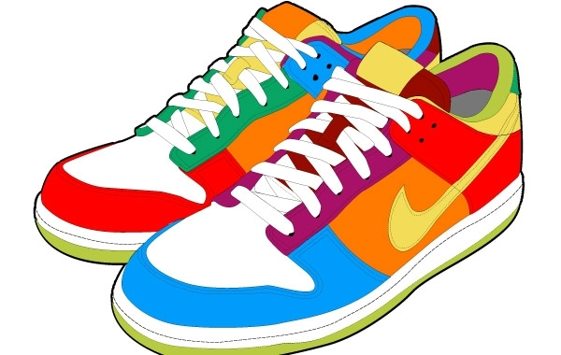
Day 1 | Day 2 | Day 3 | Day 4 | Day 5 | Day 6 | Day 7 | Day 8 | Day 9 | Day 10 | Day 11 | Day 12
Art | PE | Guid. | Music | Art | PE | Media | Music | Art | PE | SSR | Music

