The
Ms. Escobar
Grade 5
kescobar@asheboro.k12.nc.us

Classroom Newsletter
February 6, 2017



What We’re Studying
Literacy/SS – use context clues to determine the meaning of words and phrases and analyze how two texts address similar topics
Math – attributes of quadrilaterals See part of what students need to learn on the Quadrilateral Family Tree below.
Science – how the respiratory and circulatory body systems work separately and in unison

This Week and Next

*Tuesday, February 7 – report cards will be sent home
*Thursday, February 9 - First Muddy Sneakers outdoor
science exploration here on school grounds
*Friday, February 10 – Academic Celebration at 10:15 and dance after school for students
*Tuesday, February 14 – class Valentine’s Day party

We would like to have our party next Tuesday after lunch around 12:30. As part of this party, we will have a valentine exchange. I ask that each child who wants to participate bring in a valentine for every class member.

We currently have 18 students:
Boys – Nathan, Luis, Aiden, Ashton, Isaac, Bryan, and Daniel
Girls – Nikky, Analiese, Savannah, Vanessa, Olivia, Emily, Kim, Carolina, Maggie, Carlisle, and Sophie

Students may make some kind of decorated container at home if they wish in which to receive valentines from classmates. This container can be brought in next Tuesday when we have the party.

I am asking for parents to provide cakes, cookies, drinks, cups, plates, and napkins for this party. After I compile a list of what the children would like and send that out on Dojo, then you can reply back telling me what you will send. Thanks so much!!!!!
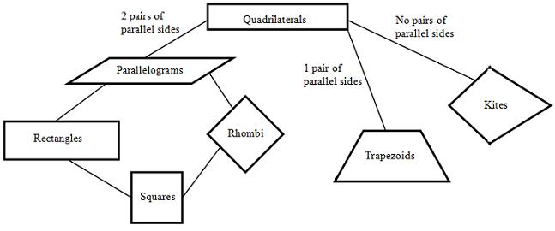

I

This Week’s Homework
MATH: Continue to study your times tables.
Monday – week 16 worksheet, 4 problems of Day 1 section
Tuesday – week 16 worksheet, 4 problems of Day 2 section
Wednesday – week 16 worksheet, 4 problems of Day 3 section
Thursday – week 16 worksheet, 4 problems of Day 4 section

SCIENCE: Get on Big Universe and read books about the digestive, respiratory, and circulatory systems of the body.

READING:
*Read 20 minutes each night from an AR book.
*Study pages 7, 8, 21, 29, and 37 from your Word Wall notebook for a quiz on Friday. These pages are synonyms for kind, negative, said, look, and think.

- 
Students have a new website written down in their planners to practice grade level math skills. They have already set up user names and passwords. This site is very kid friendly, plus they must show mastery of one skill before they can move on to the next. Our class code is 58909A. You can access this site on a computer or IPad.

Today is Day 1 of Encore, Art.

Today is Day 11 of Encore.

Day 1 | Day 2 | Day 3 | Day 4 | Day 5 | Day 6 | Day 7 | Day 8 | Day 9 | Day 10 | Day 11 | Day 12
Art | PE | Guid. | Music | Art | PE | Media | Music | Art | PE | SSR | Music

