The
Ms. Escobar
Grade 5
kescobar@asheboro.k12.nc.us

Classroom Newsletter
May 1, 2017

What We’re Reviewing
Literacy/SS – evaluate the features of an interview as an informational text
Math – multiply whole numbers with the standard algorithm
Science – water cycle

This Week’s Homework
MATH:
Monday – review the following conversions for a quiz this week:
1 foot (ft.) = 12 inches (in.)
1 yard (yd.) = 3 feet (ft.) or 36 inches (in.)
1 mile (mi) = 1,760 yards or 5,280 feet
1 pound (lb.) = 16 ounces (oz.)
1 ton (T.) = 2,000 pounds
1 pint (pt.) = 2 cups (c.)
1 quart (qt.) = 2 pints or 4 cups
1 gallon (gal.) = 4 (qts.) or 8 pints or 16 cups
0.01 meter = 1 centimeter (cm) or 10 millimeters (mm)
0.001 meter = 0.1 centimeter (cm) or 1 millimeter (mm)
1 meter (m) = 100 centimeters (cm) or 1,000 millimeters
1 meter (m) = 0.001 kilometer (km)
1,000 (m) = 1 kilometer (km)

Tuesday – Work on Study Island for 20 – 30 min. Those who don’t have the Internet have been given a paper copy to complete.
Wednesday – Learnzillion Practice Sheet, complete the four problems
Thursday – Coach book page 7 – Show your work!!

SCIENCE:
Monday – Work on Study Island for 20 – 30 min.
Tuesday – Work on Earth’s Weather Systems packet numbers 1 – 4.
Wednesday – Work on Earth’s Weather Systems packet numbers 5 – 8.
Thursday – Work on Earth’s Weather Systems packet numbers 9 – 15.
READING: Read 20 minutes each night from an AR book or work on Study Island.



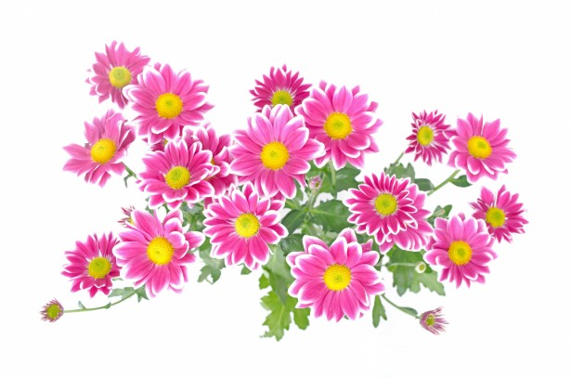





I

\

Today is day 1 of Encore.


Day 1 | Day 2 | Day 3 | Day 4 | Day 5 | Day 6 | Day 7 | Day 8 | Day 9 | Day 10 | Day 11 | Day 12
Art | PE | Guid. | Music | Art | PE | Media | Music | Art | PE | SSR | Music

