[Type sidebar title]
[Type the sidebar content. A sidebar is a standalone supplement to the main document. It is often aligned on the left or right of the page, or located at the top or bottom. Use the Drawing Tools tab to change the formatting of the sidebar text box.]
Ms. Escobar
Grade 5
kescobar@asheboro.k12.nc.us

Classroom Newsletter
September 12, 2016

This Week’s Homework

MATH: Make sure your child brings home his/her math notebook every day this week to study for Friday’s quiz on naming whole numbers and decimal places. There is a place value chart in this notebook to use as a study guide.

Tuesday - worksheet page 6, Unit 1 Whole Numbers
Wednesday - Place Value Puzzlers half-sheet worksheet
Thursday - worksheet page 1, Powers of 10 Chapter 1, Lesson 3A

SCIENCE:
Monday - Thursday
Continue to study all the terms in your science notebook as we have added new words and more information to previous terms.

READING:
Read 20 minutes nightly for pleasure.

What We’re Studying

Math – using exponents to express patterns of ten in place value from hundred billions through thousandths and multiplying and dividing numbers by multiples of 10

Science – the relationship between force and acceleration and applying vocabulary from forces and motion unit

Literacy/SS – make inferences about fixed and growth mindsets and speaker’s point of view and themes of poetry



Benchmark Assessing
• Science Benchmark (online) – tomorrow, Sept. 13
•

Our Daily Schedule

7:25 – 7:50 Morning Work
7:50 – 9:50 Literacy Block
9:50 – 11:20 Math
11:55 – 12:25 Lunch
12:30 – 12:40 Accelerated Reader
12:40 – 1:20 Science
1:20 – 1:50 Tiger Time (Review and Enrichment)
1:50 – 2:30 Encores
2:35 Dismissal

Power School
Remember to get on Power School to see your child’s grades throughout the entire year. This way there won’t be any surprises when report cards are issued. If you don’t have your login information and would like it, let me know and I’ll ask the office to print out another copy for you.

Here are some websites we used in class last week in case you’d like your child to view them again for reinforcement of concepts:
Literacy - http://mrsgraveswebsite.weebly.com/uploads/1/2/6/8/12686140/the_mysteries_of_harris_burdick.pdf (writing unit)
Math - https://www.youtube.com/watch?v=YJdCw2fK-Og (Powers of 10)
Science - https://www.youtube.com/watch?v=8iKhLGK7HGk&list=PLQlR2UEr5ah9c4Hvilx-SSwv9WwSps5-- (Bill Nye – forces)
http://www.bbc.co.uk/bitesize/quiz/q65752697 (application of vocabulary)

Today is Day 11 of Encore.

Today is Day 10 of Encore.
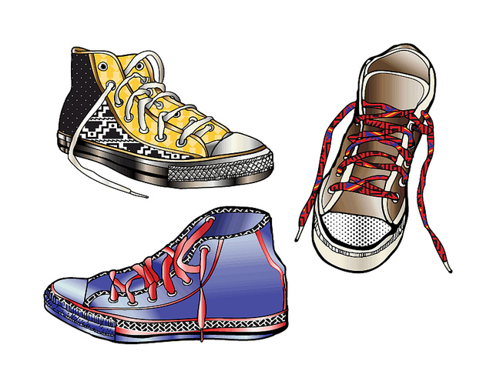
Day 1 | Day 2 | Day 3 | Day 4 | Day 5 | Day 6 | Day 7 | Day 8 | Day 9 | Day 10 | Day 11 | Day 12
Art | PE | Guid | Music | Art | PE | Media | Music | Art | PE | SSR | Music

