[Type sidebar title]
[Type the sidebar content. A sidebar is a standalone supplement to the main document. It is often aligned on the left or right of the page, or located at the top or bottom. Use the Drawing Tools tab to change the formatting of the sidebar text box.]
Ms. Escobar
Grade 5
kescobar@asheboro.k12.nc.us

Classroom Newsletter
September 19, 2016

This Week’s Homework

MATH: Make sure your child brings the math notebook home every night.

Monday - Place Value Pyramid worksheet
Tuesday - half-sheet problems 7 - 11
Wednesday - Powers of Ten, Chapter 1, Lesson 3A, problems 8-11
Thursday - Powers of Ten, Chapter 1, Lesson 3A, problems 12-15

SCIENCE: Make sure your child brings the science notebook home every night.

Monday - Thursday
Study terms 1 – 13 in your science notebook for application quiz on Friday.

READING:
Read 20 minutes nightly for pleasure.

What We’re Studying

Math – multiply copies of one unit by 10, 100, and 1,000; use exponents to name place value units; and explain patterns in the placement of the decimal point

Science – force and motion

Literacy/SS – quote accurately from a text; explain what the text says explicitly; and draw inferences from the text



FYI
The students know that they can check in Power School through their student account to see their grades, just like you can. ☺

•

Here are some websites we used in class last week in case you’d like your child to view them again for reinforcement of concepts.
Literacy https://www.youtube.com/watch?v=LUtcigWSBsw
Watch John Legend speaking about Growth Mindset using the words “persistent” and “tenacious”. Discuss what these words mean and how they relate to the growth mindset.
Math
https://www.youtube.com/watch?v=YJdCw2fK-Og
Watch the video as review. Then watch the remainder of the video to explain exponents.
Science
http://studyjams.scholastic.com/studyjams/jams/science/forces-and-motion/force-and-motion.htm

Flash Drives Please
If you could get a flash drive for your child, that would be wonderful! The flash drive can be used to save assignments that have been completed on the computer. Without the flash drive, sometimes students don’t remember where they saved their work and have to start over.

Our Daily Schedule

7:25 – 7:50 Morning Work
7:50 – 9:50 Literacy Block
9:50 – 11:20 Math
11:55 – 12:25 Lunch
12:30 – 12:40 Accelerated Reader
12:40 – 1:20 Science
1:20 – 1:50 Tiger Time (Review and Enrichment)
1:50 – 2:30 Encores
2:35 Dismissal

Today is Day 11 of Encore.

Today is Day 3 of Encore.
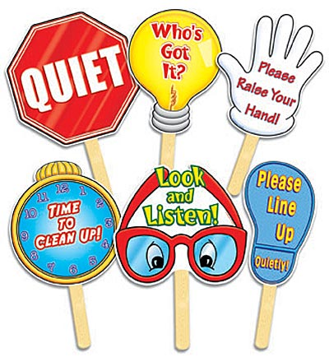
Day 1 | Day 2 | Day 3 | Day 4 | Day 5 | Day 6 | Day 7 | Day 8 | Day 9 | Day 10 | Day 11 | Day 12
Art | PE | Guid | Music | Art | PE | Media | Music | Art | PE | SSR | Music

