[Type sidebar title]
[Type the sidebar content. A sidebar is a standalone supplement to the main document. It is often aligned on the left or right of the page, or located at the top or bottom. Use the Drawing Tools tab to change the formatting of the sidebar text box.]
Ms. Escobar
Grade 5
kescobar@asheboro.k12.nc.us

Classroom Newsletter
September 26, 2016

What We’re Studying
Math – read, write, and compare decimals numbers
Science – identify and describe the forms of a solid, liquid and gas
Literacy/SS – quote accurately from a text; draw inferences from the text; determine theme of a text; use context clues to understand unknown words; and compare and contrast two characters in a text

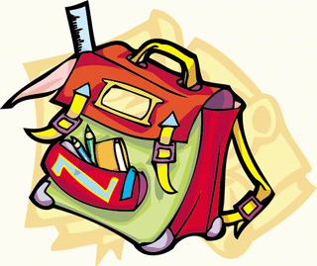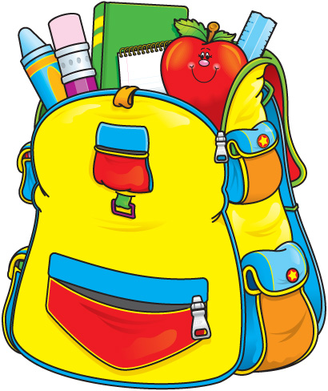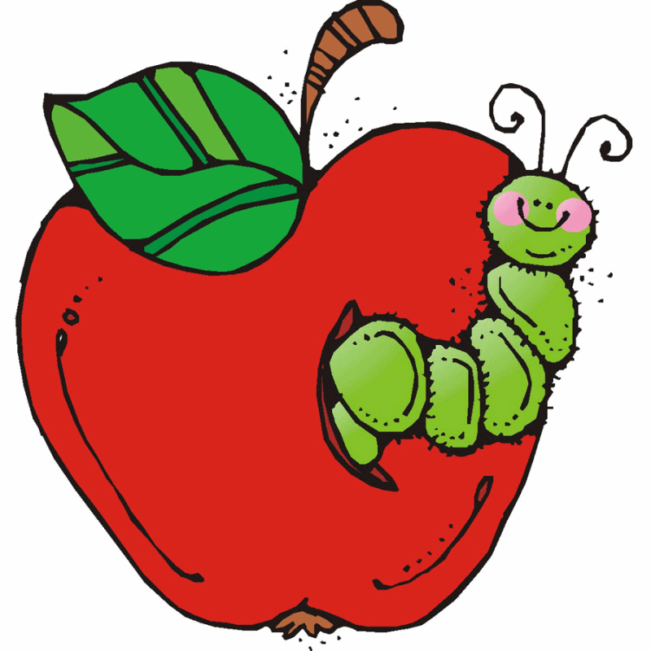

Here are some websites we used in class last week in case you’d like your child to view them again for reinforcement of concepts.
Math
https://elementarynumbertalks.wordpress.com/3rd-4th-and-5th-grade-number-talks/
Science
Jeopardy Game https://www.superteachertools.us/jeopardyx/jeopardy-review-game.php?gamefile=22685#.V9bj31srLIU

Newton’s First Law | Newton’s Second Law | Newton’s Third Law
A soccer ball will not move until it is kicked. | It takes more force to move a bowling ball than a baseball. | A rocket blasting off.
A bowling ball hitting pins and they fly backwards. | It takes less force to pull an empty wagon than a wagon with someone in it. | A fireman turns on his hose and is knocked backwards.
You are pushed back into your seat when an airplane takes off. | It takes less force to move a bicycle than a motorcycle. | The air is let of a balloon and it flies around the room.
The Law of Inertia. | A car accelerates faster than a truck. | The floor pushes up as a person’s foot pushes down.
A magician pulls out the tablecloth from under the dishes and they do not move. | The Law of Acceleration. | A swimmer pushes back on the water and moves forward.
A person’s body is thrown outward around a curve. | Pushing a child on a swing requires less force than pushing an adult. | The Law of Action/Reaction.
A picture hanging on the wall does not move. | A pitched baseball goes faster than one that is gently thrown. | Paddling a canoe.
A golf ball continues to roll until friction and gravity stop it. | An ice skater pushes with more force and begins to move faster. | A cannonball shot forward and the cannon moves back.
A pencil on a table will stay there until someone picks it up. | A full grocery cart grocery cart requires more force to push than an empty cart. | Sitting in a chair, you exert a force on the chair and it exerts an equal force on you.
Ascending in an elevator and blood rushes to your head when it suddenly stops. | Several dogs pulling a sled cause it to go faster than just one dog pulling a sled. | A bird pushes down on the air with its wings in order to fly.
An object at rest will remain at rest and an object in motion will remain in motion until acted upon by an unbalanced force. | The force of an object is equal to its mass multiplied by its acceleration. | For every action there is an equal and opposite reaction.

This Week’s Homework

MATH: Make sure your child brings the math notebook home every night for review.
Monday - Understand Place Value worksheet PS 1, 1 - 8
Tuesday - Color-Coded Costumes worksheet
Wednesday - Making Money worksheet page 147
Thursday - Decimal Detective worksheet
SCIENCE: Make sure your child brings the science notebook home every night.
Monday - Thursday
Students should bring home their Newton’s Laws sort activity in a brown envelope in their Homework Folders, and practice every night. The answer key, to help your child sort or check work is on this newsletter.
READING:
Read 20 minutes nightly for pleasure.

Today is Day 11 of Encore.

Today is Day 8 of Encore.
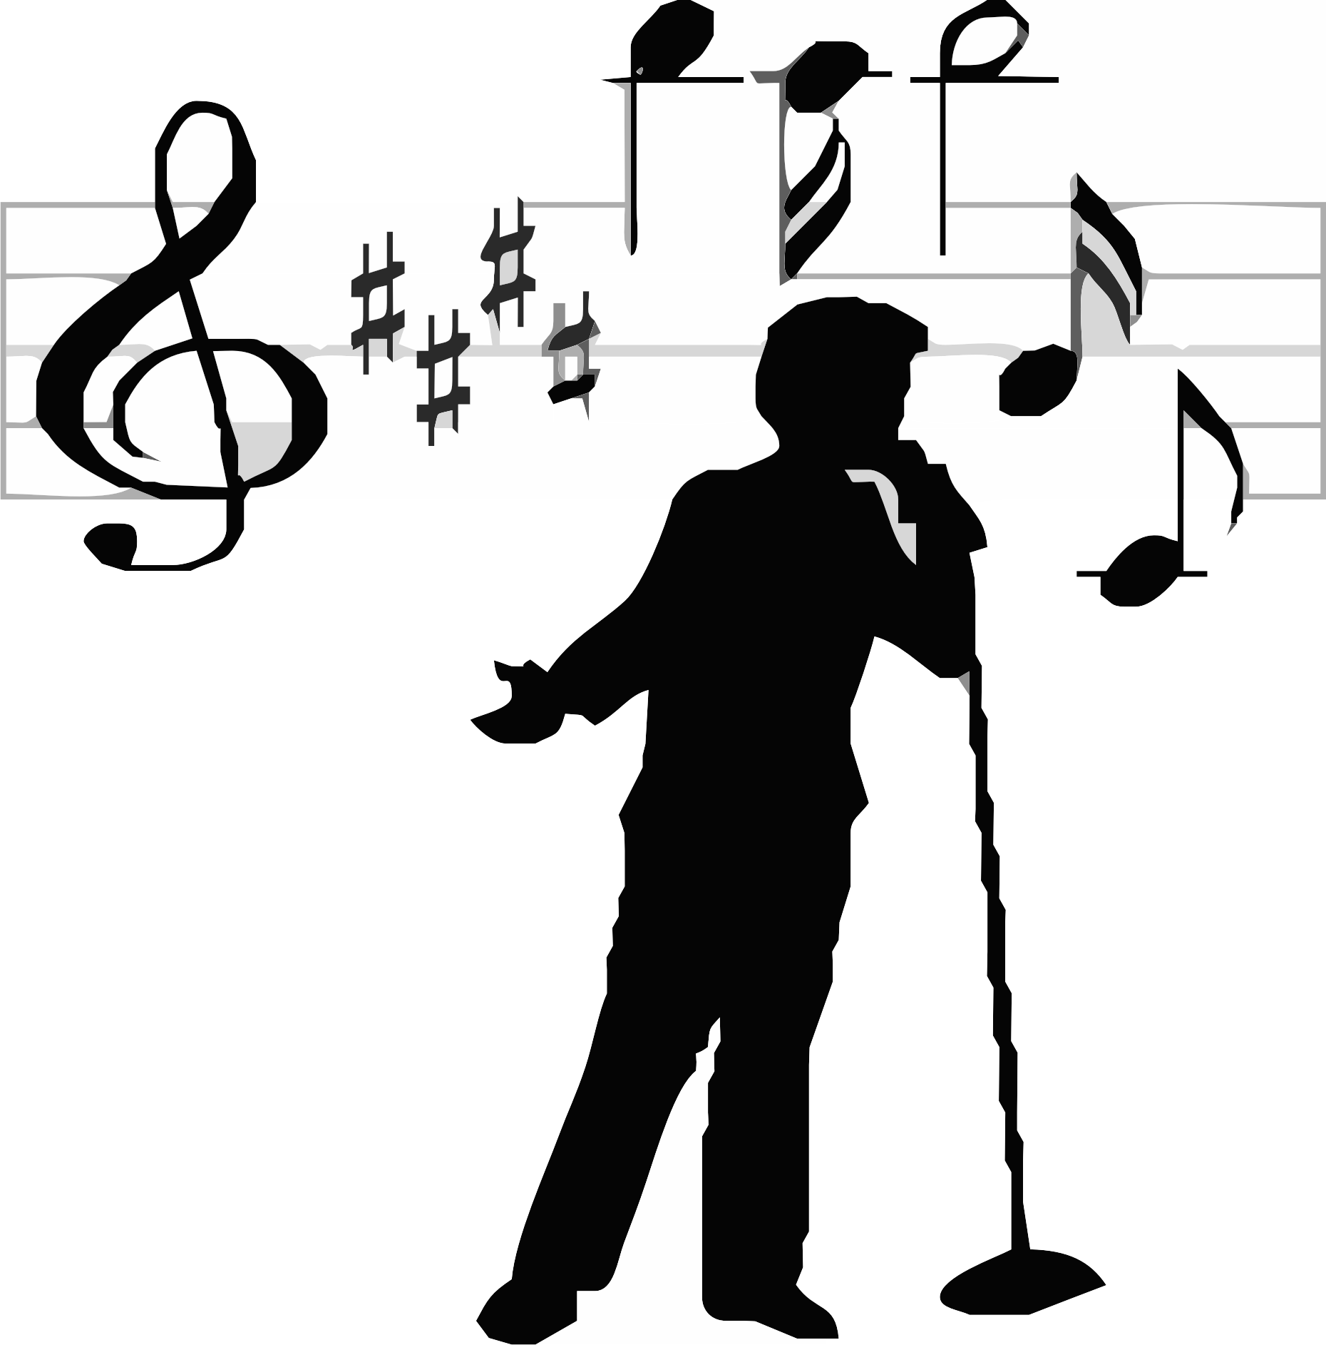
Day 1 | Day 2 | Day 3 | Day 4 | Day 5 | Day 6 | Day 7 | Day 8 | Day 9 | Day 10 | Day 11 | Day 12
Art | PE | Guid | Music | Art | PE | Media | Music | Art | PE | SSR | Music

