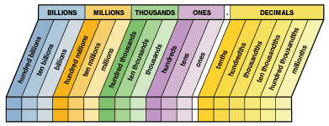
Place Value Chart – Students must be able to know all 3 places in the billions, million, thousands, and ones period.
You say the word “and” for the decimal point when reading numbers.
Students need only to know the tenths, hundredths, thousandths, and ten thousandths places of the decimals period.

