Place Value Unit Test Study Guide Worth 2 Grades
- Vocabulary
digits – 0 – 9 The digits in 322 are 3 and 2.
expanded form – 300 + 20 + 2 or (3X10X10)+(2X10)+(2X1)
standard form – 322
value – The value of the 3 in the number 322 is 300.
written or word form – three hundred twenty-two

- Writing Numbers in Word Form and Expanded Form
word form | standard form
five thousand, two hundred fifty-six | 5,256
five thousand, two hundred fifty-six and three tenths | 5,256.3
five thousand, two hundred fifty-six and three hundredths | 5,256.03

thirty - five thousand, two hundred fifty-six and eighty-seven hundredths | 35,256.87
nine hundred twelve million, two thousand seventeen | 912,002,017
nine hundred twelve million, two thousand seventeen and five hundred fifty-one thousandths | 912,002,017.551

- Writing Whole Numbers & Decimals in Expanded Form Using Exponents and Powers of 10
Standard Form | Expanded Form | Expanded From Using Powers of 10 and Exponents
5 | 5 x 1 | 5 x 10º
56 | (5 x 10) + (6 x 1) | (5 x 10¹)+ (6 x 10º
567 | (5 x 100) + (6 x 10) + (7 x 1) | (5 x 10²)+ (6 x 10¹)+ (7 x 10º
5678 | (5 x 1,000) + (6 x 100) + (7 x 10) + (8 x 1) | (5 x 10³)+ (6 x 10²)+ (7 x 10¹)+ (8 x 10º
Standard Form | Expanded Form Using Powers of 10 and Exponents | Written/Word Form
5.4 | (5 x 10⁰) + (4 x 0.1) | five and four tenths
56.25 | (5 x 10¹)+ (6 x 10⁰)+ (2 x 0.1) + (5 x 0.01) | fifty-six and twenty-five hundredths
956.7 | (9 x 10²)+ (5 x 10¹)+ (6 x 10⁰)+ (7 x 0.1) | nine hundred fifty-six and seven tenths
456.789 | (4x10²)+ (5x10¹)+ (6x10⁰)+ (7x0.1) + (8x0.01) + (9x0.001) | four hundred fifty-six and seven hundred eighty-nine thousandths

- Rounding Whole Numbers and Decimals
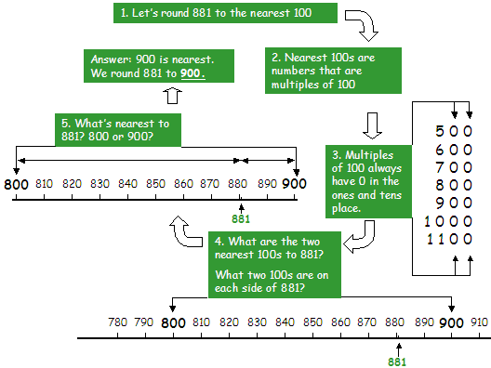

How to round to the nearest 100
Steps | Example 1 | Example 2 | Example 3 | Example 4
Let’s round a number to the nearest 100. | 441 | 178 | 922 | 4568
Underline the ten's place. | 441 | 178 | 922 | 4568
If it is less than 5, round down. | 400 |  | 900
If it is 5 or more, round up. |  | 200 |  | 4600

Example: Round 74 to the nearest 10
- The next digit is "4" which is less than 5, so no change is needed to "7" Answer: 70
Example: Round 86 to the nearest 10 Answer: 90 (86 gets "rounded up")
- We want to keep the "8"
- The next digit is "6" which is 5 or more, so increase the "8" by 1 to "9"

Rounding Decimals
First you need to know if you are rounding to tenths, hundredths, or thousandths. That tells you how much of the number will be left when you finish.
Examples | Because ...
3.1416 rounded to hundredths is 3.14 | ... the next digit (1) is less than 5
1.2635 rounded to tenths is 1.3 | ... the next digit (6) is 5 or more
1.2635 rounded to 3 decimal places is 1.264 | ... the next digit (5) is 5 or more
134.9 rounded to tens is 130 | ... the next digit (4) is less than 5
12,690 rounded to thousands is 13,000 | ... the next digit (6) is 5 or more
1.239 rounded to units is 1 | ... the next digit (2) is less than 5

- Comparing Whole Numbers & Decimals Using <, >, or =
Step 1: Line up the numbers by place value. Be sure to line up the decimal points. | Step 2: Compare the digits in the greatest place value. | Step 3: Compare the digits in the next greatest place value until you find a difference.
Whole Number Example:  7,428  7,435 | 7,428  7,435  The greatest place value is the one furthest to the left. Here it is the thousands place. | Same Same Different  7, 4 2 8  7, 4 3 5  Therefore:  7,428 < 7,435  Because the 3 in tens place is greater than the 2 in the tens place.
Decimal Example:  57.62  57.289 | 5 7 .62  5 7 .289  The greatest place value is the one furthest to the left. Here it is the tens place. | Same Same Different  5 7 . 6 2  5 7 . 2 8 9  Therefore:  57.62 > 57.289  Because the 6 in the tenths place is greater than the 2 in the tenths place.

- Ordering Decimals: Least to greatest or greatest to least
Step 1: Line up the numbers by place value. Be sure to line up the decimal points. | Step 2: Compare the digits in the greatest place. Compare the digits in the next greatest place and continue. | Step 3: Rewrite the numbers in the required order. (Greatest to Least OR Least to Greatest)
Decimal Example:  4.28  42.8  4.29 | 4 . 2 8  4 2 . 8  4 . 2 9  ** 42.8 is automatically greatest because it has a digit in the tens place.  * 4.28 is least because the 8 in the hundredths place is less than the 9 in the hundredths place. | Greatest to Least:  42.8; 4.29; 4.28  Least to Greatest:  4.28; 4.29; 42.8

